Script is able to reset Windows Update or Fix Windows Update, and modify files and registry settings.

**Requirements**

Windows XP and above

**Installation**

Requires no installation

Method to use Windows Update Tool (WUT)

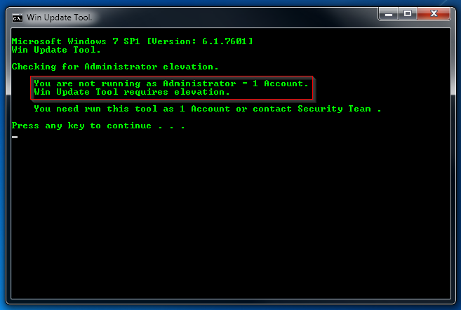

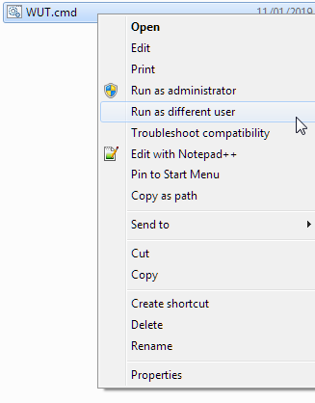

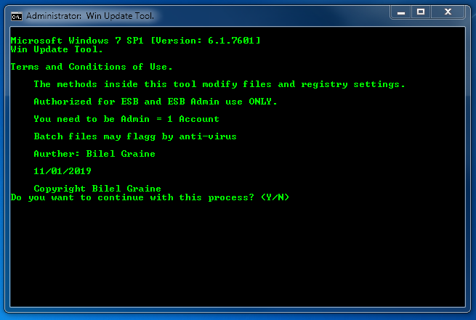

Type Y

